Unit 1 Social Studies Study Guide

**Things to know:**

* 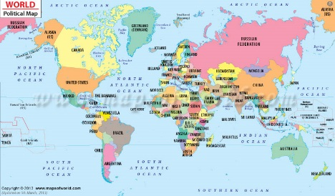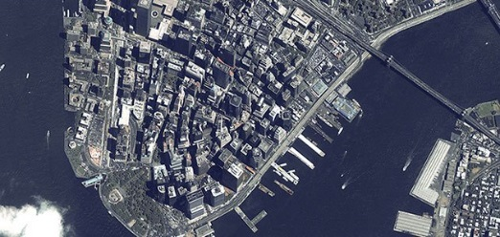Types of maps:

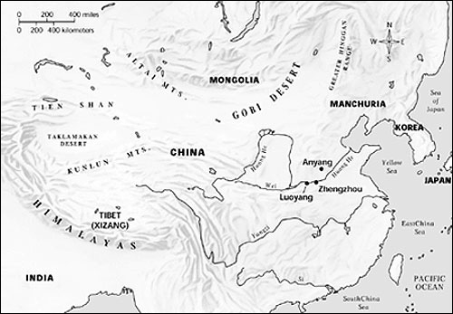

Political Map Physical Map Satellite Image

* A **political map** focuses on boundaries between locations, like countries, states, or counties. They generally use brighter colors to easily distinguish the boundaries.
* A **physical map** often includes much of the same data found on a political map, but their primary purpose is to show landforms like deserts, mountains, and plains.
* A **satellite image** is a picture of an area taken by a satellite in space.
* What is a globe?
* Parts of a map:

legend: an explanation of the symbols on a map or chart, also called a key

compass rose: a device that shows the cardinal and intermediate directions

scale: represents distances on a map

* Review the packet called, “Where on Earth?”
  + Latitude, Longitude
  + Prime Meridian, Equator
  + Hemispheres (Which 2 continents are mostly in the Western Hemisphere?)
  + Cardinal Directions: North, South, East, West
* Review landform terms: island, mountain, peninsula, desert, rainforest
* Review climates: tropical, arctic, rainforest, desert
* There are many advantages of living near bodies of water, which is why many people chose to live and work there.

🟋For extra review, see the “Tracy Traveler” Talking Book Power Point on my website under “Social Studies Review.”